



**Disclaimer: The content is curated from online/offline resources and used for educational purpose only**

**LAB MANUAL**

**Unit III – Machine Learning**

**Unit III – Machine Learning**

**Lab 6. Clustering Energy Consumption Patterns for Smart Cities**

**Objective**

This lab focuses on using clustering techniques to identify patterns in energy consumption data for smart cities. By understanding these patterns, city planners and utility providers can optimize energy distribution, reduce waste, and promote sustainability in urban areas.

**Problem**

Urban areas experience fluctuating energy demands based on factors such as population density, time of day, and weather conditions. Identifying clusters of similar energy consumption patterns can provide insights into high-demand areas, predict peak usage, and implement efficient energy-saving strategies. The goal is to use clustering algorithms to group similar energy consumption profiles, enabling smart city initiatives to optimize resources and promote sustainable living.

**Solution**

To create the Classifying Waste Types for Recycling (to classify them into different categories: Plastic, Metal, Organic, ) using classification algorithms

following steps:

1. Import required libraries
2. Prepare the dataset
   1. Load Dataset
   2. Data cleaning and preprocessing
   3. Select features and normalize the data
3. Elbow Method to find the optimal number of clusters
4. Evaluate the model performance
5. Visualization

**Procedures**

**1. Import required libraries**

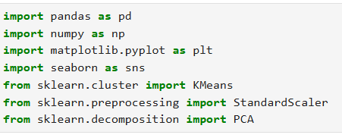

**2. Prepare the dataset**

**2.1 Load Dataset**

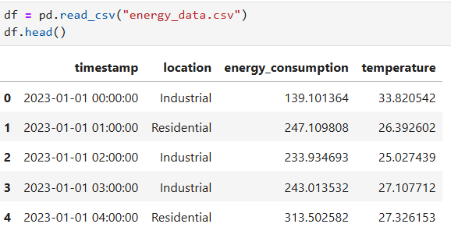

**2.2 Data cleaning and preprocessing**

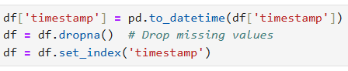

**2.3 Select features and normalize the data**





**3. Elbow Method to find the optimal number of clusters**

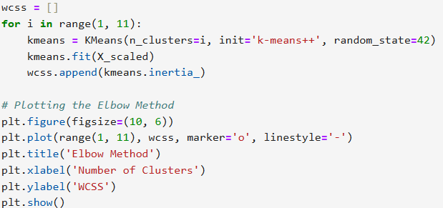

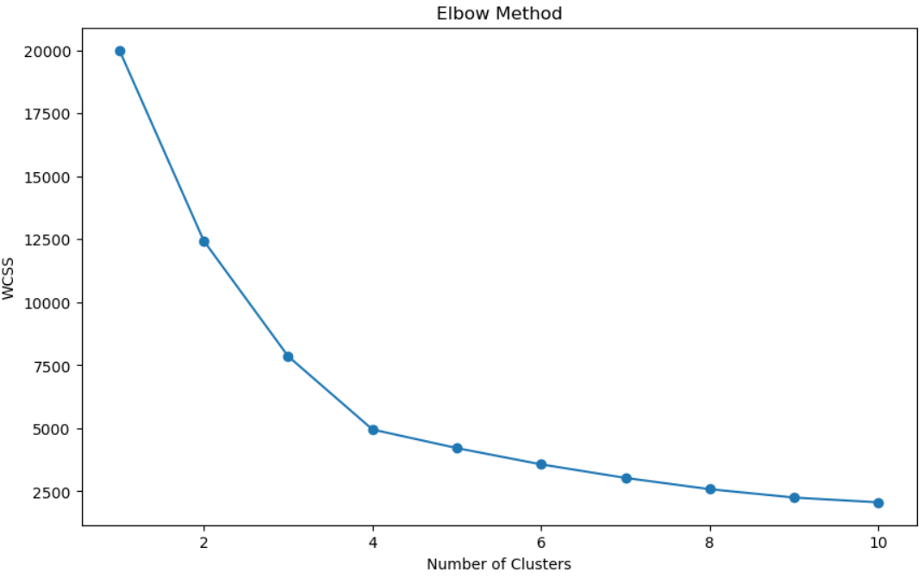

**4. Evaluate the model performance**

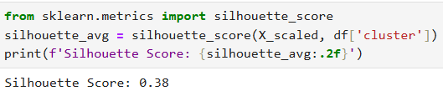

**5. Visualization**

